Personal Portfolio Website
The Developers Arena – Web Development Internship Task: Week 1 – HTML: Your First Website

Project Description
The Personal Portfolio Website is a simple website created using HTML to introduce myself, showcase my technical skills and projects, and provide contact information. This project
helped me understand the basic structure of a website.

Technologies Used
  - HTML5
  - Visual Studio Code
  - Web browser (Google Chrome)
  - Git and GitHub

Project Features
  - Home section with an introduction
  - About Me section
  - Technical Skills section
  - Projects section
  - Contact form with basic validation
  - Navigation links between sections
  - Profile image with alternative text
  - Semantic HTML elements such as header, nav, main, and footer
Note: The contact form demonstrates basic validation. It does not send messages to an email address.

Project Folder Structure
  - index.html – Main webpage
  - README.md – Project documentation
  - images/profile.jpg – Profile image

How to Run the Project
- Download or clone the project repository from GitHub.
- Open the project folder in Visual Studio Code.
- Locate the index.html file.
- Open index.html in a web browser to view the website.
- Navigate through the sections and test the contact form.

Screenshots
Screenshot 1: Home Section

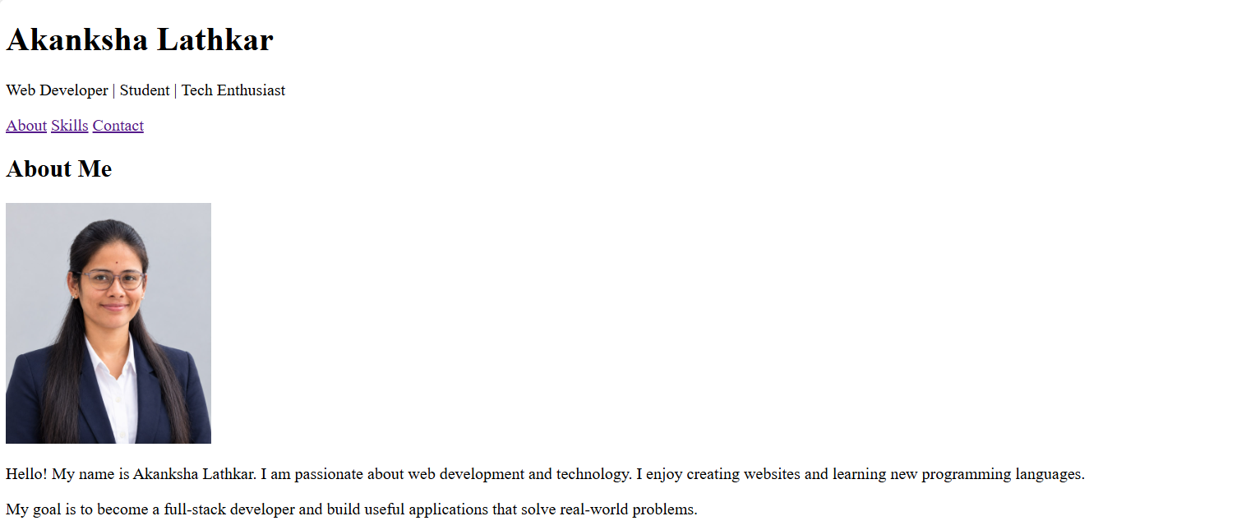
Screenshot 2: About and Skills Sections

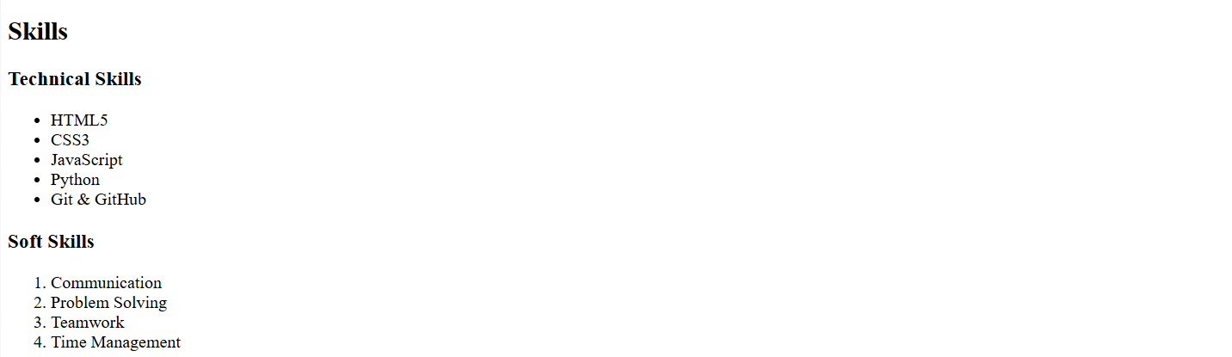
Screenshot 3: Contact Sections
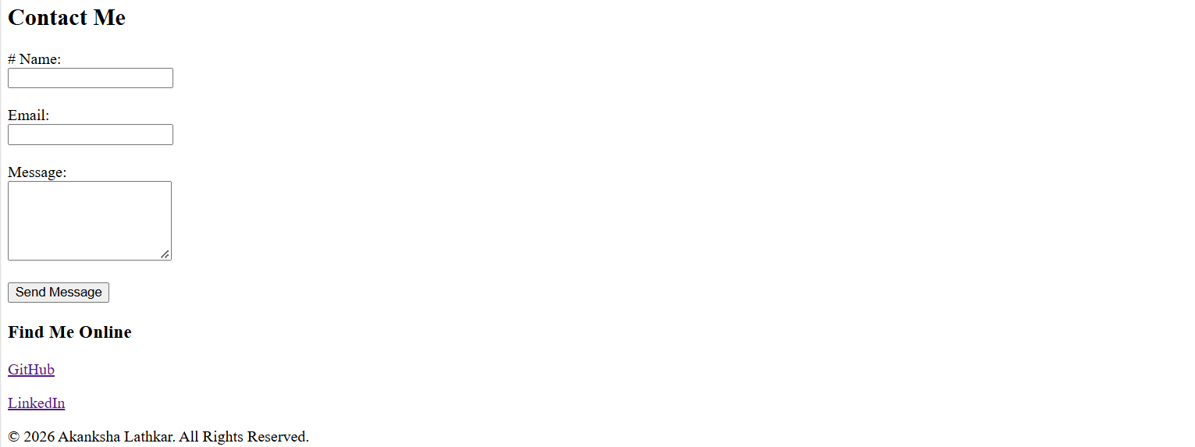

- What I Learned
Through this project, I learned how to create an HTML webpage, organize content into
sections, use headings and links, add images with alt text, create a basic contact form, and manage project files using GitHub.

Future Improvements
  - Add CSS to improve the website's design and responsiveness.
  - Use JavaScript to add more interactive features.
  - Connect the contact form to a backend or form service to send messages.

G. GitHub Repository

https://github.com/akankshalathkar41-oss/Internship.git

